**Kiln Questionnaire**

1. **Indicate the nature of this application**

**Customer Information**

Name:……………………………………………………….

Organisation:…………………………………………….

…………………………………………………………………

Address:………………………………………………….  
  
…………………………………………………………..…..  
  
…………………………………………………………..……  
  
…………………………………………………………..……

Postcode:……………………………………………..…

Daytime tel no:………………………………………..

**Invoice Address if different from above**

Address:………………………………………………….  
  
…………………………………………………………..…..  
  
…………………………………………………………..……  
  
…………………………………………………………..……

Postcode:……………………………………………..…

Daytime tel no:………………………………………..



Kiln enquiry

Kiln order





1. **Type of kiln required**  
     
   Front loading









Top loading

1. **Product Code/s of Kiln**

………………………………………………………………..

1. **Power Supply available at final location**

Single Phase Amps 32 / 40 / 50 / 63 circle which applies

Three Phase Amps 10 / 15 / 20 circle which applies

**Access into the building**





**5.0)** Entrance to be used Main

Back









Service

**Office use only**

Customer ref:…………………………………………

Our ref:…………………………………………………….

Daytime tel no:…………………………………………

**Supplier Acknowledgement:**

Name (Printed)…………………………………………

Date: ………………………………………………………

Signature: ………………………………………………

Other (state)………………………

**5.1)** Type of surface from

vehicle to building: Tarmac

Concrete

Gravel

Other (state)…………………….

**5.2)** Parking facilities or restrictions:……………………………………………………………………………………

**5.3)** Number of steps at entrance:…………………………… if the entrance has more than two steps the kiln may have to be built on site at extra cost

**5.4)** Width of steps at entrance:………………………………

**5.5)** Depth of steps:……………………………………………

**Access to kiln site location**

**6.0)** Name of kiln site:……………………………………………….

* 1. Floor Number: ………………………………………………….
  2. Room Number:………………………………………………….
  3. Number of steps en route:……………………………………..
  4. Width of steps:…………………………………………………..
  5. Length of corridor to site:………………………………………
  6. Width of corridor:……………………………………………….
  7. Number of bends:………………………………………………
  8. Floor surface of corridor:………………………………………

**6.9)** Width of narrowest door:………………………………………





Are you prepared to remove doors? Yes No

Width when removed:………………………………………………

Any other obstructions?..........................................................................................................................................

…………………………………………………………………………………………………………………………………

…………………………………………………………………………………………………………………………………

**Note!** All measurements should take permanent obstructions into consideration, e.g. radiators, firehouses etc. Measurements should relate to the most difficult types of obstacles en route.

**Lifts**





**7.1)** Is there a lift available: Yes No

**7.2)** Does the lift stop at the correct floor: Yes No





**7.3)** Maximum allowable lift load:………………………… Ibs/Kgs (delete)

**7.4)** Any other information?............................................................................................................................  
  
..............................................................................................................................................................................

**Optional Extras**

If the kiln is not being positioned in a secure room then we recommend a kiln cage.





Would you be interested in receiving details for a kiln cage? Yes No





Will you require an on-site build quotation? Yes No

**Kiln Considerations for Installation and Ventilation**

**Installation**

1. **Room Conditions**
   * The installation space is dry, weatherproof and waterproof. [ ] Yes [ ] No
   * The room temperature is between +5°C and +30°C. [ ] Yes [ ] No
   * For room temperatures higher than 30°C the controller can be adjusted. Will you require this?   
     [ ] Yes [ ] No
2. **Floor Requirements**
   * The floor is level and non-combustible (e.g., concrete, tiles, aluminium, or steel). [ ] Yes [ ] No
   * The floor can support the weight of the kiln and accessories. [ ] Yes [ ] No
3. **Movement and Stability**
   * If the kiln has castors, the brakes are locked during firing. [ ] Yes [ ] No
   * The kiln will be allowed to settle for 24 hours before first use. [ ] Yes [ ] No
4. **Safety Spacing**
   * **Top Loading Kilns:** There is a 0.5m safety gap around all sides. [ ] Yes [ ] No
   * **Front Loading Kilns:** There is a 0.5m gap from the walls and 0.7m at the rear. [ ] Yes [ ] No

**Kiln space requirements should be added to the drawing**. This ensures you have proper clearance around and above your kiln, it is free from combustibles and there is proper space for user access and engineer maintenance safety.

Kiln room to be sized as, kiln footprint + plus dimensions shown above. Note full height shelving or cupboard should be treated as external walls for sizing purposes.

Kiln can be offset sideways in a room, to a minimum of 400mm to wall, but overall dimensions must remain.  
NOTE: Space behind kiln is fixed for engineers safety. Pipework in drawing is shown for example.

A kiln room must have proper forced extraction and air inlet.

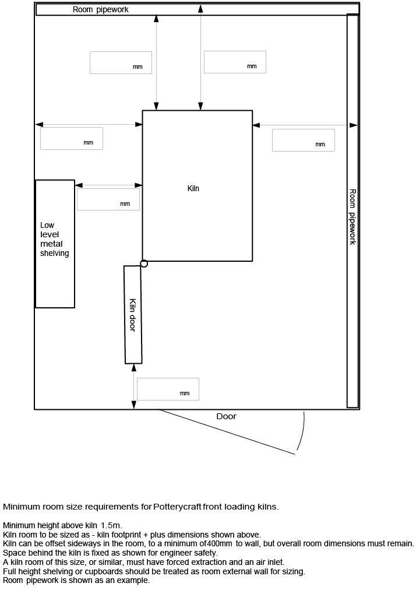

1. **Ceiling Requirements**
   * There is a 1.5m clearance between the kiln and the ceiling and free from overhead storage and obstructions [ ] Yes [ ] No
   * Combustible ceilings are protected with heat-resistant boards (10cm gap). [ ] Yes [ ] No
2. **Doors and Windows**
   * Air inlets and outlets are installed for ventilation in separate rooms. [ ] Yes [ ] No
   * Fire doors, if present, have grating for airflow. [ ] Yes [ ] No
3. **Kiln Cages (Optional)**
   * A lockable, earth-bonded cage is installed for safety. [ ] Yes [ ] No
4. **If there is a fire alarm and/or smoke detector in the room of where the kiln is situated, the customer must seek advice inform the Fire Alarm Maintenance team.**

**Ventilation**

1. **General Ventilation**
   * There is an airflow through the room during kiln firing. [ ] Yes [ ] No
2. **By Kiln Size**
   * **Small Kilns (Up to 6 kW):** A window or extraction fan is available for ventilation. [ ] Yes [ ] No
   * **Medium Kilns (6 to 15 kW):** An extraction fan and air bricks are installed. [ ] Yes [ ] No
   * **Large Kilns (15 to 32 kW):** Extraction fans, air bricks, and a canopy system are installed. [ ] Yes [ ] No
3. **Extraction Systems**
   * A canopy is installed (if required) for efficient heat and fume removal. [ ] Yes [ ] No
   * A ventilation specialist has been consulted for high-temperature solutions. [ ] Yes [ ] No
4. **Replacement Air**
   * An external air source is available to replace extracted air. [ ] Yes [ ] No

**Additional Guidelines**

1. Fire safety materials are used in the kiln room. [ ] Yes [ ] No
2. The premises have been advised to update the Fire risk assessment following installation. [ ] Yes [ ] No
3. Manufacturer recommendations are followed to avoid warranty avoidance. [ ] Yes [ ] No

**Important**

Please complete this kiln questionnaire fully to ensure we quote correctly.

Unless you wish to collect, we deliver the kiln using our own transport and will notify you of the delivery date in due course.

Please note that our responsibility will end with the standard delivery**\***of the kiln to the specified address. However, our drivers may be able to assist negotiate doors, passageways etc. It must be understood, however, that once the kiln has been off- loaded from our lorry, additional assistance is given at the customer’s risk. We provide equipment for the unloading the kiln and transporting it to the ground floor.

* Standard delivery means off-loading the goods to outside threshold of door with reasonable assistance. Standard delivery is made on the assumption that the chosen site for the kiln and access to that site has the approval of your architect, builder or electrician relative to the standard and type of building etc.

If we consider it impossible to place the kiln in the position selected, our responsibility ends with the delivery of the kiln to your door. Should we need to return at a later date to assist installation and/or test the kiln additional costs will be incurred.

Should you have any difficulties with any of the conditions stipulated or in completing this questionnaire, please do not hesitate to contact us.

*I have read the above document and understand the kiln installation and ventilation requirements.*

Signed: ………………………………………………………………………… Date: ……………………………………………

Print Name: ………………………………………………………………………………………………………………………………………………………………..

Organisation Name: …………………………………………………………………………………………………………………………………………………

For Supplier to sign-

Signed: ………………………………………………………………………… Date: ……………………………………………



**Dryad Educational. Home of Specialist Crafts**

**UK** :Tel: (+44) 0116 269 7711 **Email:**post@speccrafts.co.uk **Web:** www.specialistcrafts.com

**IRE:** Tel: (+353) 091 768 809 **Email:** office@dryadeducation.ie **Web**: www.dryadeducation.ie

**UAE:** Tel: (+971) 014 348 6744 **Email:** speaktous@dryadeducation.ae **Web**: [www.dryadeducation.ae](http://www.dryadeducation.ae)